Title: Gift Registry

Group: Kevin Whalen, Kyle Meehan, Vidmantas Steponavicius

Description:

For our database project, we decided to build a gift registration system known as Gift Registry. The system would catalog a person who would receive gifts, the gifts, the people who would buy the gifts, and where the user would receive the gifts. The system will achieve keeping and displaying this catalog through a mobile web application on the front end and a PHP driven MySQL database on the backend.

The intended users of the Gift Registry application would be any one who hosts an event in which he or she would receive a number of various gifts. For example, the event could be a bridal shower, a birthday party, a baby shower, or any number of other events. The people purchasing gifts for those events are also intended to use the system. The host would add those people as guests to the underlying database via a friendly mobile web application interface. After that, the host would also specify the gifts he or she would like to receive. They may add to a gift list by scanning the bar code of their desired gifts. The guests can then access the wish list of gifts for that person’s event. As the gifts are being bought, the guest giving the gift would be able to mark it as purchased. In the underlying database, this is just a Boolean flag. Since each gift is identified with a bar code, the Gift Registry would be store independent which would serve to simplify buying the gifts.

The main advantage of a gift registration system is that since the user specifies what gifts he or she would want to receive, the receiver’s friends do not have to come up with gift ideas by themselves. Another advantage of this application is that its users would be able to add items at any time or place via the internet on a mobile web application that can make use of the Android bar code scanner. Previous gift registration systems exist to help guest shop for people’s events and parties, but they do not usually show what gifts have already been purchased. As guests are liable to buy the host the undesirable presents or duplicate gifts, our new system can prevent that from happening. Previous systems are also only designed around use in a single store. Our idea is store independent, so the users are not limited in what they gifts they can specify they want.

Example:

 Say, for instance, a user’s birthday is going to happen soon. If a user wanted to create a gift registry for his or her birthday, then he or she could use our Gift Registry application. First the user would create his or her account or login if he or she already had an existing one.

Then, he or she would create an event and name it birthday. The user could specify a location to host his or her birthday and when it would occur. The user would then add items they would like to receive by scanning their barcodes and would then invite people to the event.

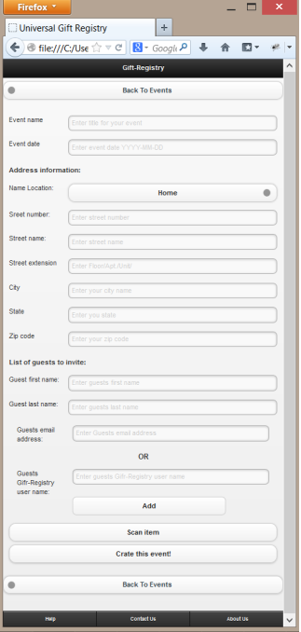

Those users who were invited will confirm whether or not they can come and check off items from the gift list they have purchased. They do not necessarily have to come to the event in order to purchase presents. The users who were invited can also say they aren’t coming if they later discover that they are unable to attend.

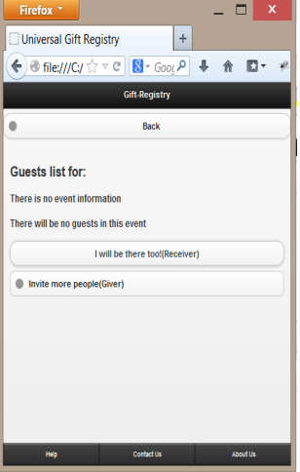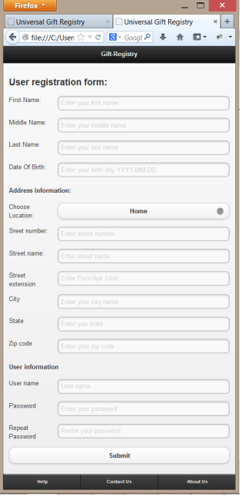

After the event has happened, it would be added to an old event archive.

